**Instructions:**Replace **[bracketed red text]** with the requested information or screen capture.  
Replaced **bracketed red text with black text**.  
Do not include full screen shot images, or full screen shots that are reduced in size. Use a snippet tools to capture parts of the screen and insert those images into the template.  
Do not remove tags from this template. All fields are required.  
Assignment questions are not as detailed as activity questions.   
The assignment is where you demonstrate understanding of the material.  
Assignment - Questions and Answers:   
Assignment questions are not as detailed as activity questions.   
The assignment is where you demonstrate understanding of the material.  
  
Part A - Student Information:   
**1. Student Name: Brian Salinas**

**2. Class Designation: IN-CLASS**

**3. Did you complete the activity before starting this assignment? Yes**

**4. Did you work with any other students on this assignment? No**

**5. What day and date did you start this assignment? 03/03/19**

**6.** Go back to the instructions and continue with Part B.Part B –Drupal CMS Webhost Information:

**1. Which web host did you use for this assignment, Shared web-host (SiteGround), Code Anywhere (CA), Cloud9 (C9), OR Pantheon (PA)?**

**SiteGround**

Part C - Drupal CMS Website Information

If you used a shared web host fill out the information below:

1. **Assignment Website In-Directory Name:** **mod8assignment8**
2. **Assignment MySQL Database Information**
   * **Database Name: drup181**
   * **Table Prefix:** **drfl_**
3. **WEBSITE Admin Username:** **brianlbg**
4. **WEBSITE Admin Password:** **aca42196975**
5. **Assignment Website URL:** http://brians3.sgedu.site/mod8assignment8/

After creating the Drupal site, go back to the instructions and continue with Part D.

Part D – Harden the Drupal 7 Site:

1. Why should you harden your Drupal 7 site?

**In order to prevent bots from creating and spamming new accounts on my site [D01]**

1. SCREEN CAPTURE of Backend Configuration > Account settings, REGISTRATION AND CANCELATION settings  
   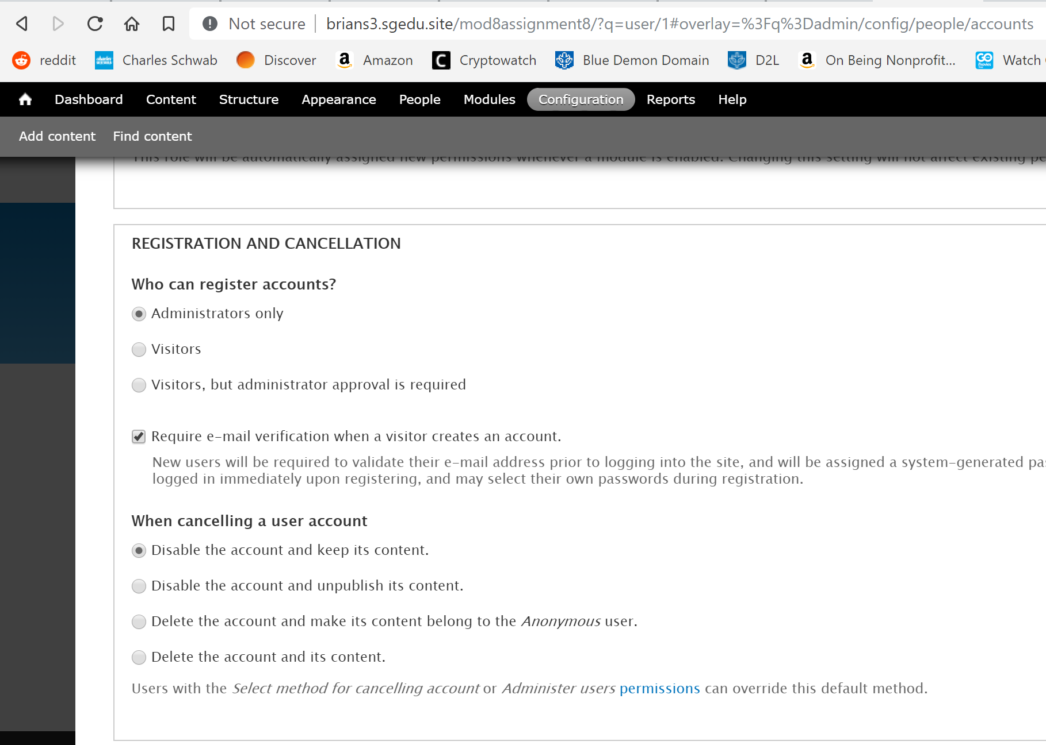 **[D02]**
2. SCREEN CAPTURE of the Frontend website Front (Home) Page, as an anonymous user, demonstrating that an anonymous user cannot signup for a new account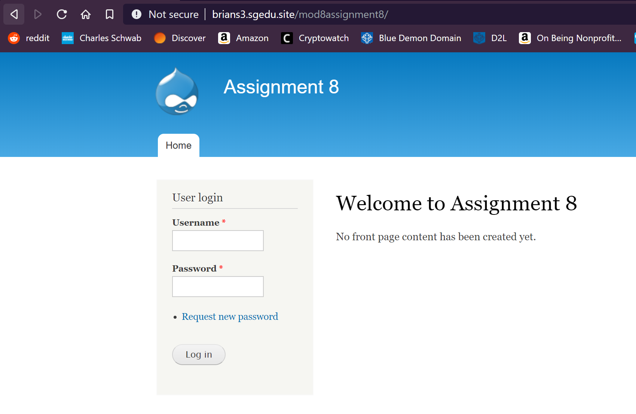 **[D03]**
3. Go back to the instructions and continue with Part E.

Part E – Extend the Drupal 7 Site with Modules, Libraries and Themes

1. SCREEN CAPTURE of Backend Admin toolbar > Appearance showing Responsive Green as Default theme  
   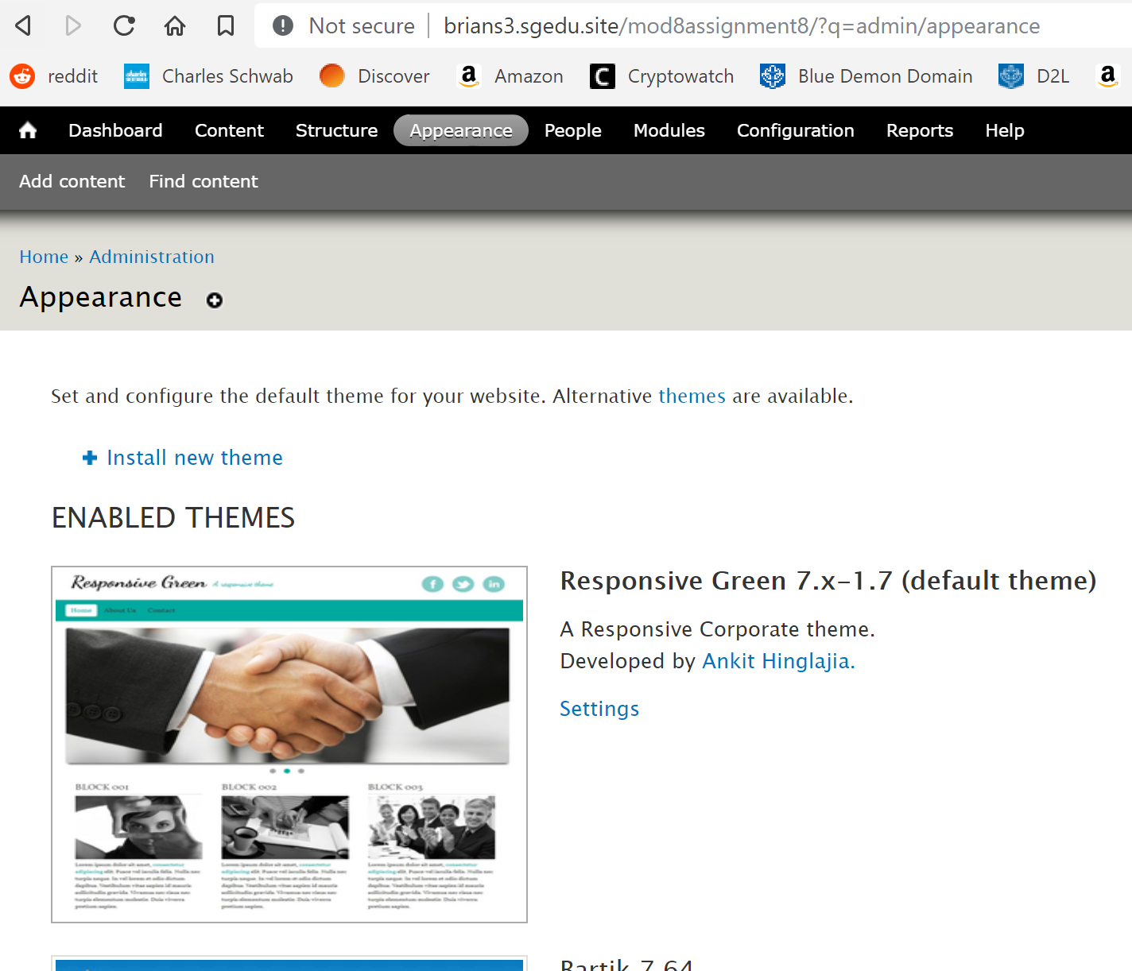 **[E01]**
2. SCREEN CAPTURE of Backend Admin toolbar > Appearance Seven as Admin theme  
   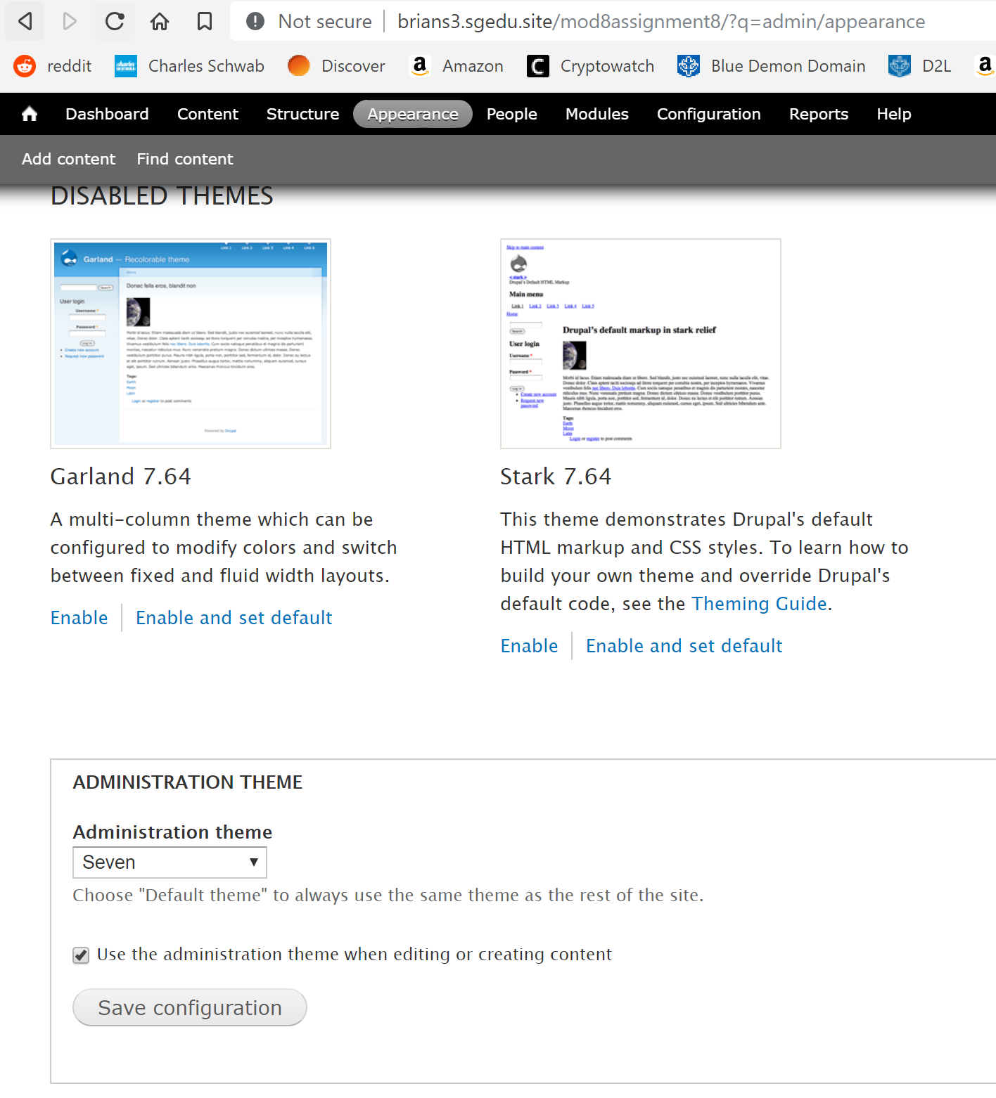**E02]**
3. SCREEN CAPTURE of Backend Responsive Green settings showing slideshow disabled   
   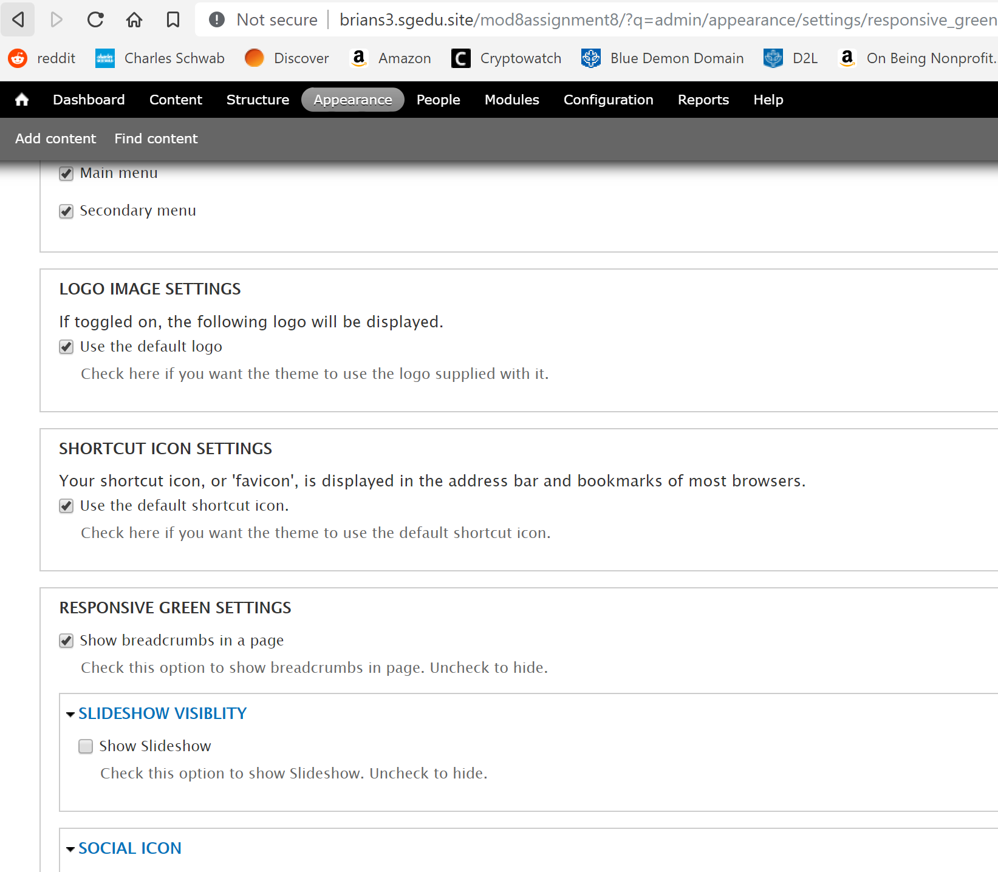 **[E03]**
4. **Which Wysiwyg module or Module or Module + JavaScript Library did you install?  
   CKEditor [E04]**
5. SCREEN CAPTURE of Backend +Add new Basic page with the Wysiwyg toolbar above Body   
   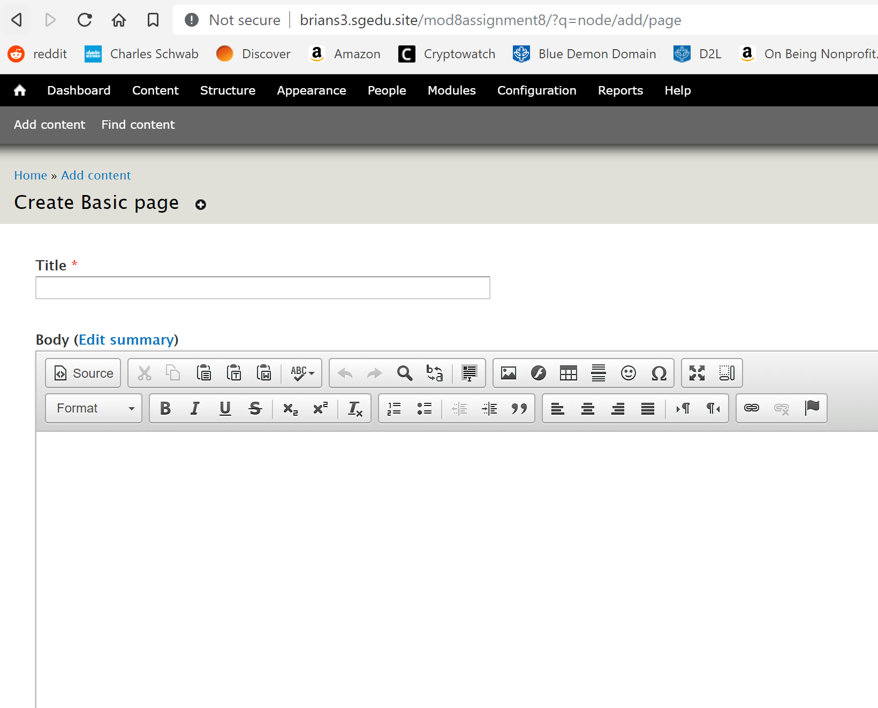 **[E05]**
6. Go back to the instructions and continue with Part F.

Part F - Drupal 7 – Taxonomy, vocabulary and Terms

1. SCREEN CAPTURE of Backend Structure > Taxonomies (list of Vocabulary names)   
   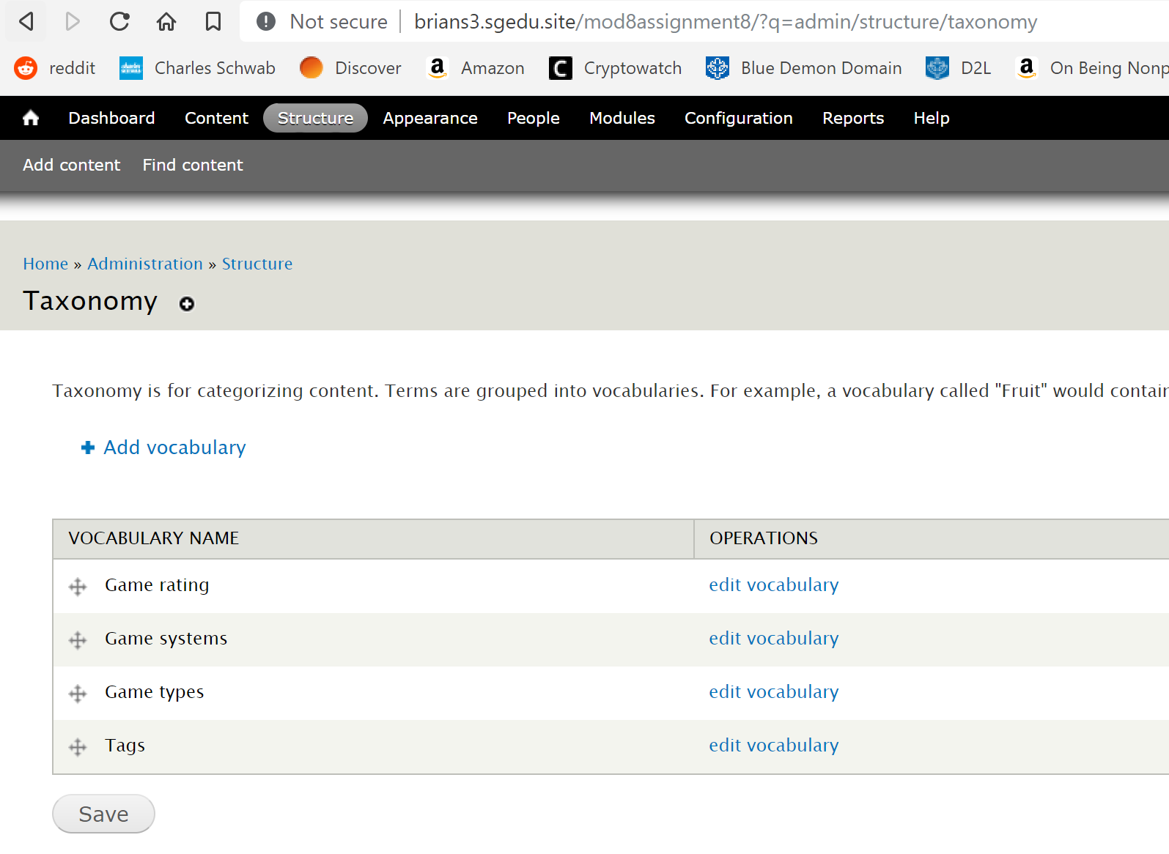 **[F01]**
2. SCREEN CAPTURE of Backend Structure > Taxonomies, list terms for **Game rating** vocabulary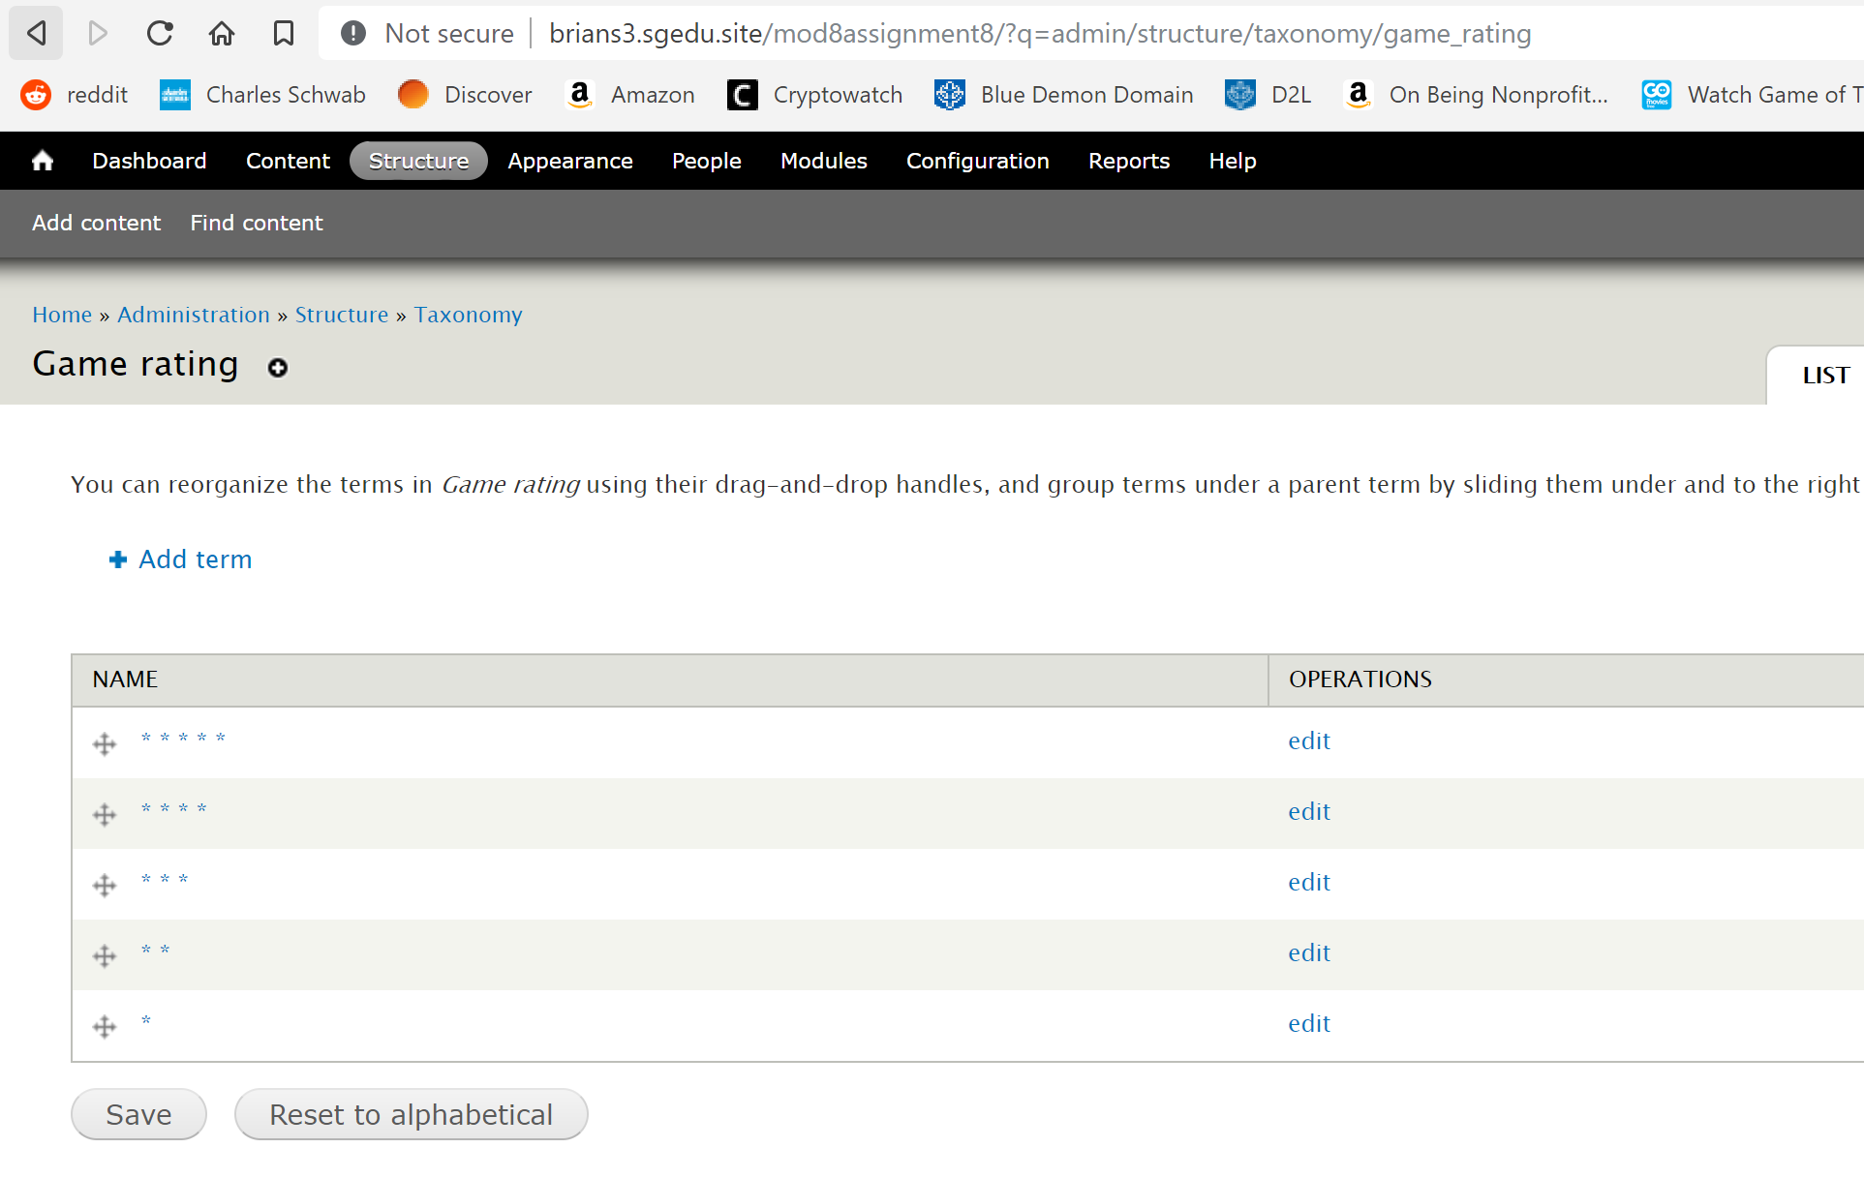 **[F02]**
3. SCREEN CAPTURE of Backend Structure > Taxonomies, list terms for **Game types** vocabulary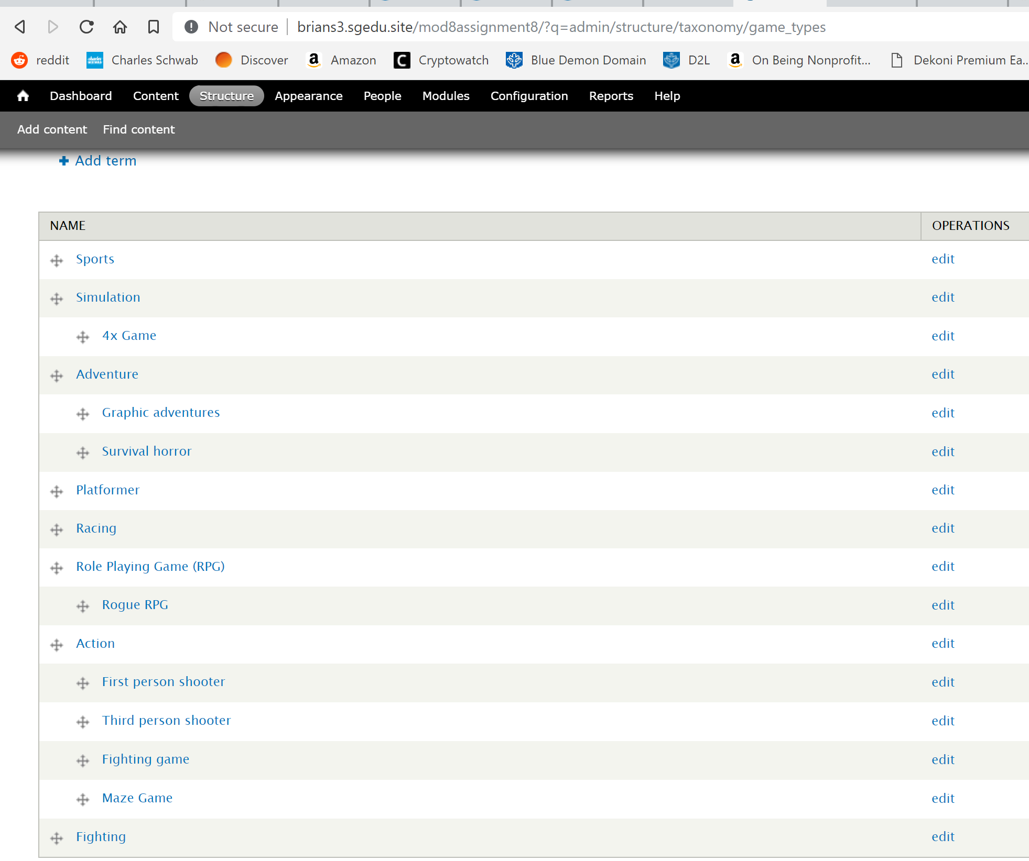 **[F03]**
4. SCREEN CAPTURE of Backend Structure > Taxonomies, list terms for **Game systems** vocabulary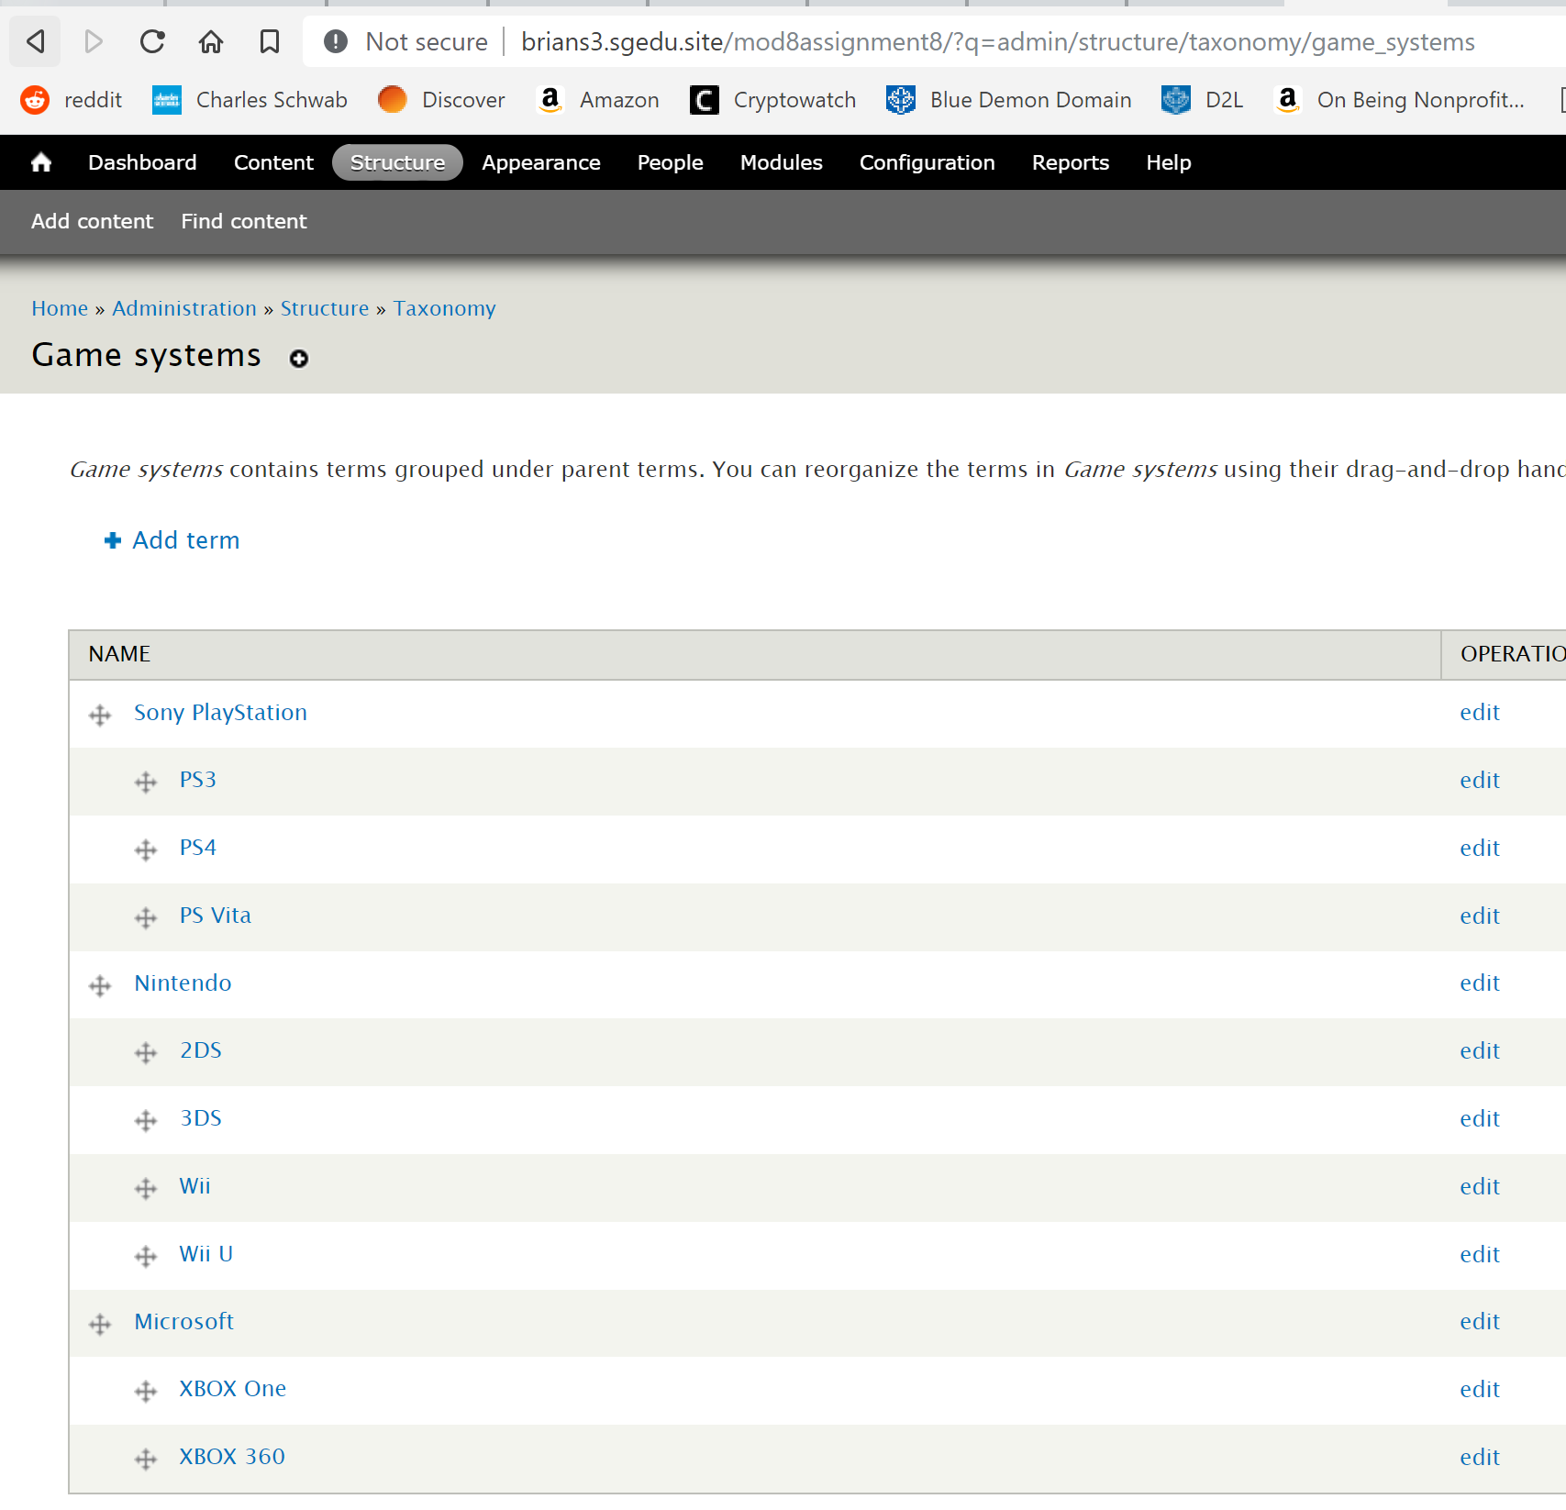 **[F04]**
5. Go back to the instructions and continue with Part G.

Part G - Create new content type named “Video games”

1. SCREEN CAPTURE of Backend Structure > Content types, Video Games EDIT TAB page   
   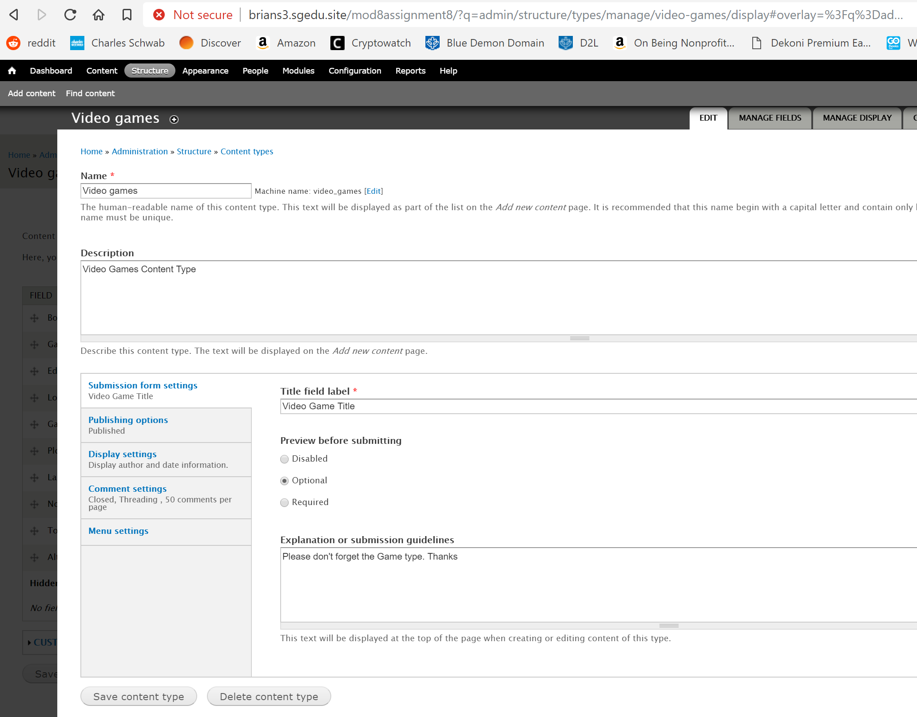 **[G01]**
2. SCREEN CAPTURE of Backend Structure > Content types, Video Games MANAGE FIELDS TAB page 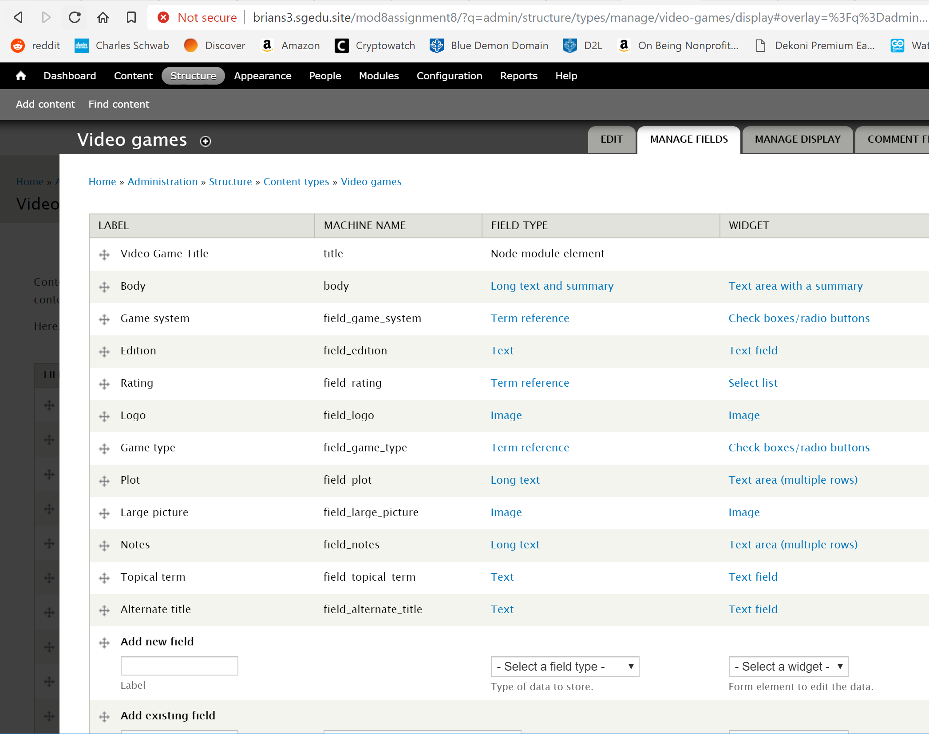 **[G02]**
3. SCREEN CAPTURE of Backend Structure > Content types, Video Games MANAGE DISPLAYT TAB page 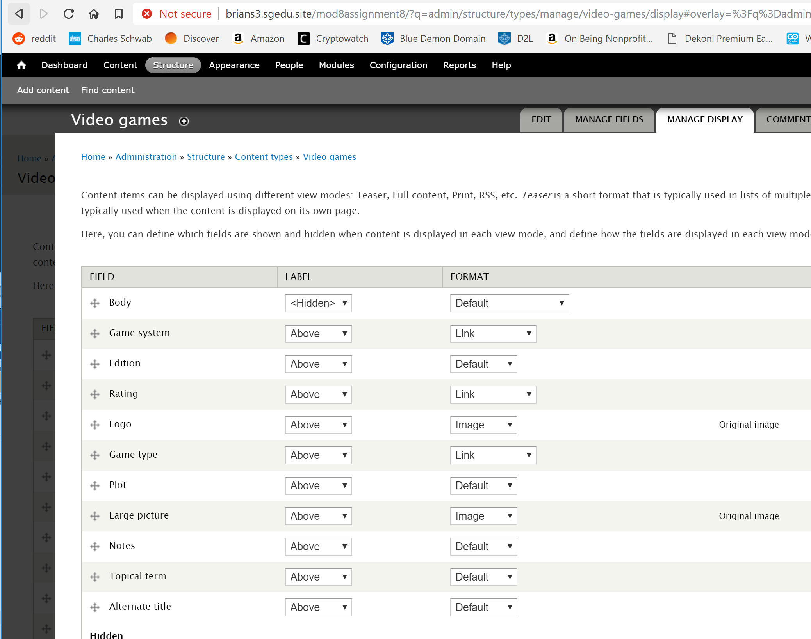 **[G03]**
4. Go back to the instructions and continue with Part H.